# **Name: Abdurrahman Qureshi**

# **Roll No: 210451**

Practical No: 12

1. Write a Program to validate Name, Age, Date of Birth, Email and Password.

PHP CODE:

<?php

if (isset($_POST['name']) && isset($_POST['age']) && isset($_POST['email']) && isset($_POST['dob']) && isset($_POST['password'])) {  
 $name = $_POST['name'];  
 $age = $_POST['age'];  
 $email = $_POST['email'];  
 $dob = $_POST['dob'];  
 $password = $_POST['password'];  
  
 if (empty($name) || empty($email) || empty($age) || empty($dob) || empty($password)) {  
 header('Location: ./WBPExperiment12_HTML.php?error=Details cannot be empty');  
 exit();  
 } elseif (!filter_var($email, *FILTER_VALIDATE_EMAIL*)) {  
 header('Location: ./WBPExperiment12_HTML.php?error=Invalid Email Address');  
 exit();  
 } elseif (!is_numeric($age) || $age <= '0' || $age >= '90' || $age != '19') {  
 header('Location: ./WBPExperiment12_HTML.php?error=Invalid Age');  
 exit();  
 } elseif ($name === 'qarq90' && $email === 'qarq90@gmail.com' && $password === 'bloodonhands' && $dob === '2005-01-17') {  
 header('Location: ./WBPExperiment12_HTML.php?success=Details Verified');  
 exit();  
 } else {  
 header('Location: ./WBPExperiment12_HTML.php?error=Details do not match expected values');  
 exit();  
 }  
} else {  
 header('Location: ./WBPExperiment12_HTML.php?error=All fields are required');  
 exit();  
}

HTML CODE:

<!DOCTYPE html>  
<html lang="en">  
<head>  
 <meta charset="UTF-8">  
 <meta name="viewport" content="width=device-width, initial-scale=1.0">  
 <title>Form Validation</title>  
 <link rel="stylesheet" href="WBPExperiment12_CSS.css">  
</head>  
<body>  
<h2>Form Validations</h2>  
<form method="post" action="./WBPExperiment12_PHP.php">  
  
 <?php if (isset($_GET['success'])) { ?>  
 <p class="success"><?php echo $_GET['success'] ?></p>  
 <?php } ?> <br>  
  
 <label for="name">Name:</label>  
 <input type="text" id="name" name="name">  
 <?php if (isset($_GET['error'])) { ?>  
 <p class="error"><?php echo $_GET['error'] ?></p>  
 <?php } ?> <br>  
  
 <label for="age">Age:</label>  
 <input type="text" id="age" name="age">  
 <?php if (isset($_GET['error'])) { ?>  
 <p class="error"><?php echo $_GET['error'] ?></p>  
 <?php } ?> <br>  
  
 <label for="dob">Date of Birth:</label>  
 <input type="date" id="dob" name="dob">  
 <?php if (isset($_GET['error'])) { ?>  
 <p class="error"><?php echo $_GET['error'] ?></p>  
 <?php } ?> <br>  
  
 <label for="email">Email:</label>  
 <input type="text" id="email" name="email">  
 <?php if (isset($_GET['error'])) { ?>  
 <p class="error"><?php echo $_GET['error'] ?></p>  
 <?php } ?> <br>  
  
 <label for="password">Password:</label>  
 <input type="password" id="password" name="password">  
 <?php if (isset($_GET['error'])) { ?>  
 <p class="error"><?php echo $_GET['error'] ?></p>  
 <?php } ?> <br>  
  
 <input type="submit" name="submit" value="Submit">  
</form>  
</body>  
</html>

CSS CODE:  
.success {  
 width: 200px;  
 padding: 1rem;  
 background-color: lime;  
 color: black;  
}  
.error {  
 width: 200px;  
 padding: 1rem;  
 background-color: red;  
 color: white;  
}  
label {  
 display: inline-block;  
 width: 150px;  
}  
input {  
 display: inline-block;  
 width: 150px;  
}

OUTPUT:

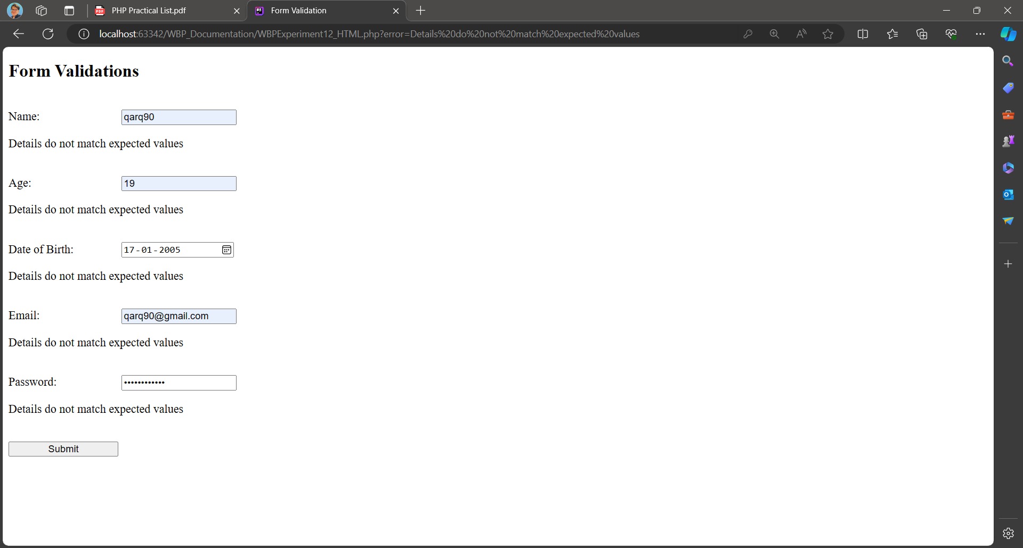

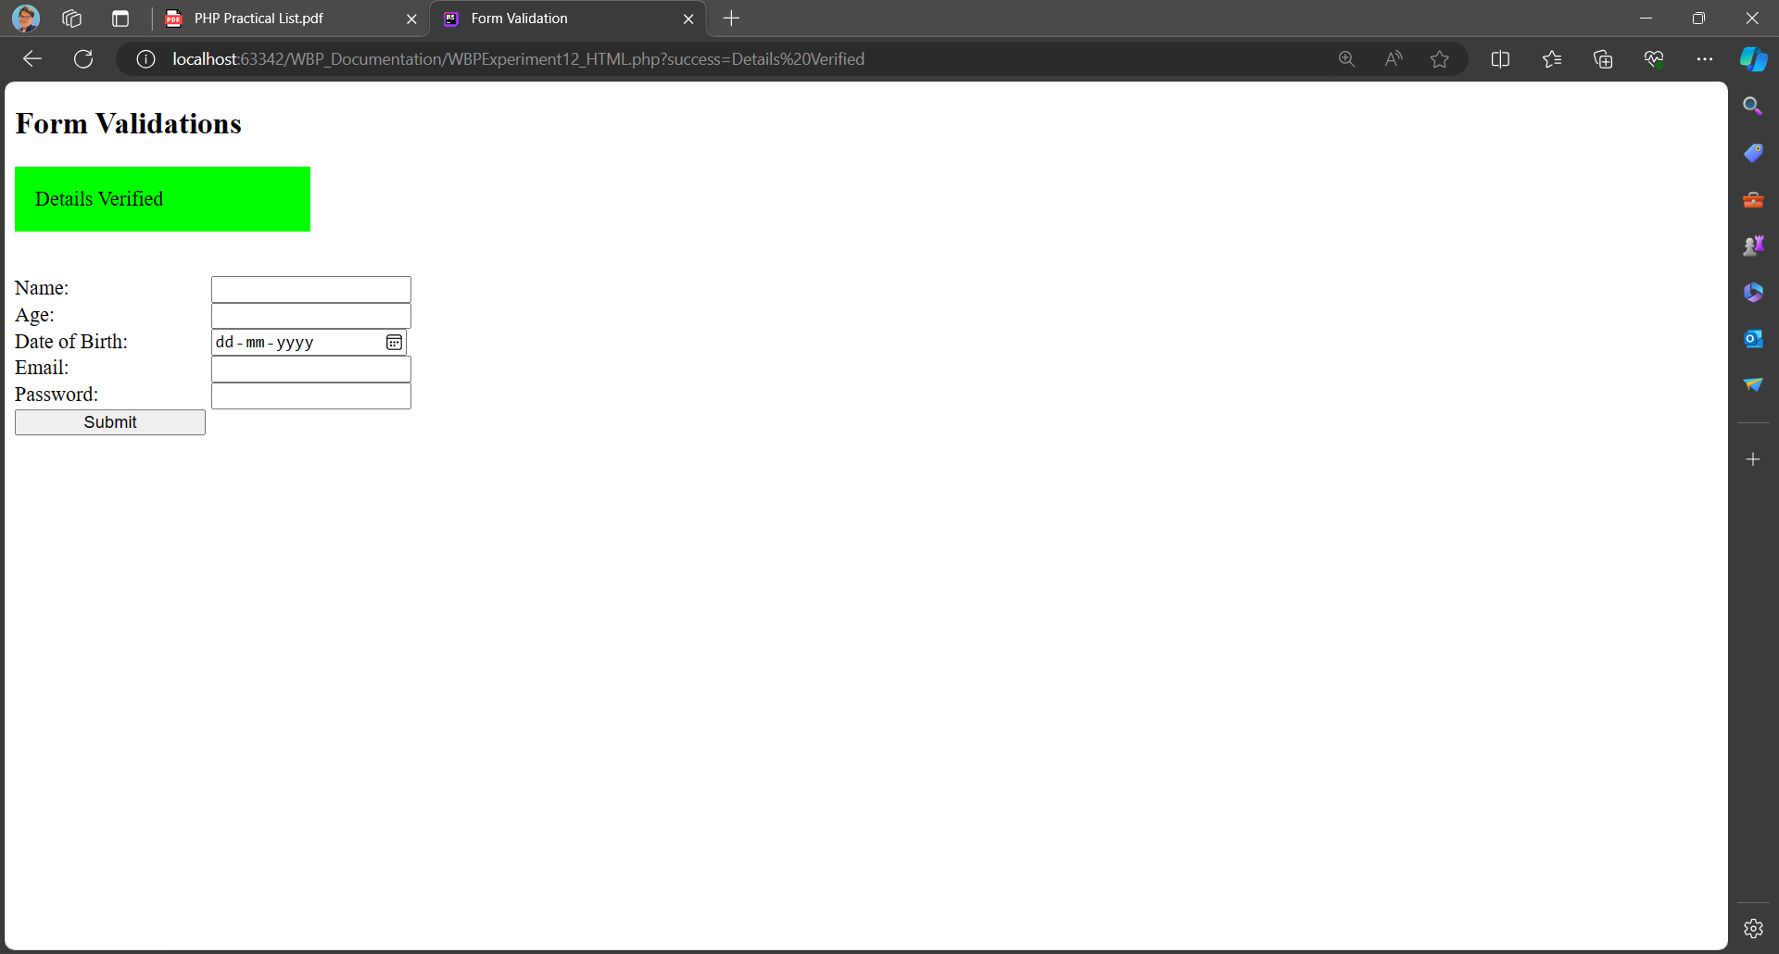

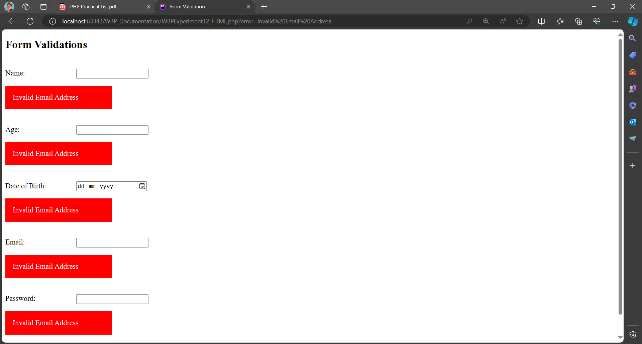

1. Write a Program to validate IP address.

PHP CODE:

<?php  
function validateIPAddress($ip) {  
 if (filter_var($ip, FILTER_VALIDATE_IP)) {  
 return true;  
 } else {  
 return false;  
 }  
}  
  
$ip1 = "192.168.0.1";  
$ip2 = "256.256.256.256";  
$ip3 = "abc.def.ghi.jkl";  
  
echo "IP 1: " . ($ip1 . (validateIPAddress($ip1) ? " is valid" : " is invalid")) . "\n";  
echo "IP 2: " . ($ip2 . (validateIPAddress($ip2) ? " is valid" : " is invalid")) . "\n";  
echo "IP 3: " . ($ip3 . (validateIPAddress($ip3) ? " is valid" : " is invalid")) . "\n";

OUTPUT:

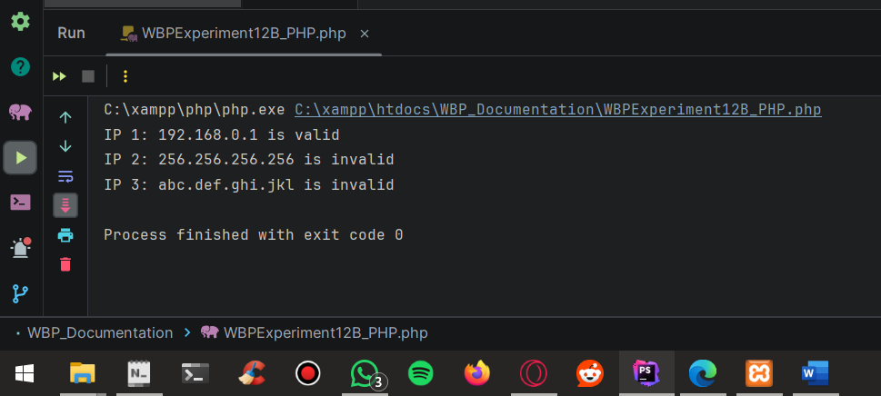

1. Write a Program to validate company specific email.

PHP CODE:

<?php  
  
function validateCompanyEmail($email) {  
 $pattern = '/^[a-zA-Z0-9._%+-]+@outlook\.com$/';  
  
 if (preg_match($pattern, $email)) {  
 return true;  
 } else {  
 return false;  
 }  
}  
  
$email1 = "qarq90@outlook.com";  
$email2 = "sattarbaksh@example.com";  
  
echo "Email 1: " . ($email1 . (validateCompanyEmail($email1) ? " is a valid company email" : " is not a valid company email")) . "\n";  
echo "Email 2: " . ($email2 . (validateCompanyEmail($email2) ? " is a valid company email" : " is not a valid company email")) . "\n";  
  
?>

OUTPUT:

